Continuing Education Requirements
The real estate agent licensing continuing education requirements are established by the Maryland Real Estate Commission (MREC). The required hours must be completed during the term of the license and 30-days prior to submitting a renewal application. Inactive Licensees must complete all hours due for each renewal period prior to submitting a reactivation application.
The current requirements can be found on the Real Estate Commission website:
https://www.dllr.state.md.us/license/mrec/mreceduc.shtml

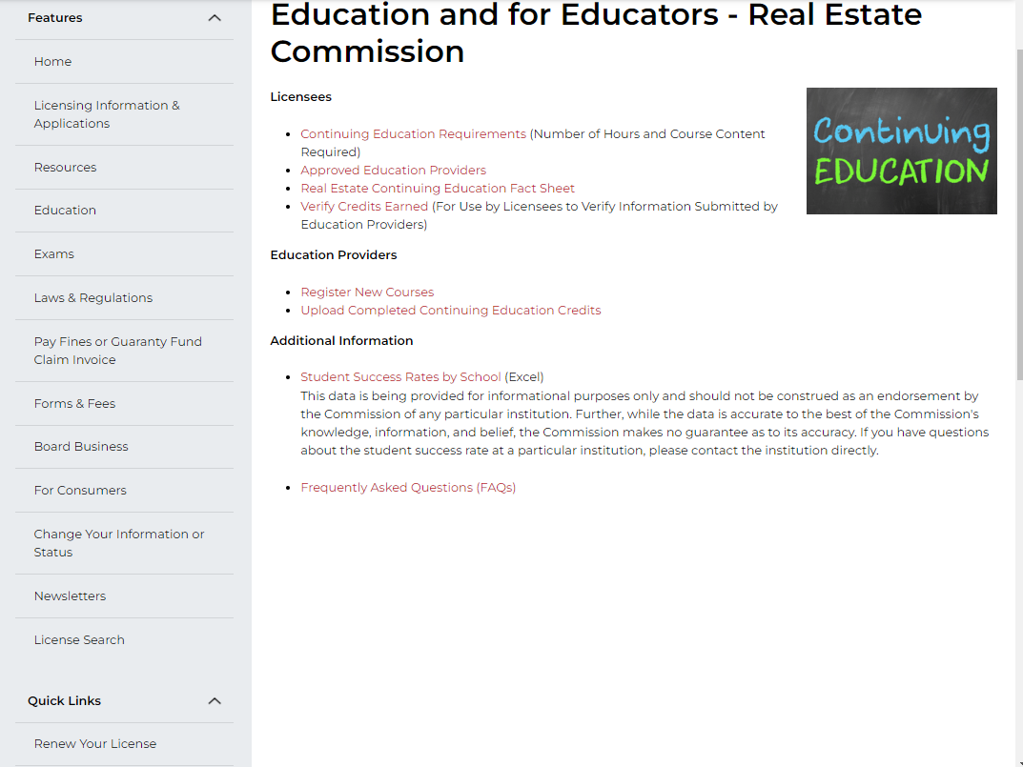
All continuing education classes completed at a MREC licensed school will be uploaded by the school and posted on your education portal page in the MREC; which can be viewed by clicking on the “Verify Credits Earned” link. It is your responsibility to verify that the classes have been posted.
Best practice is to renew your license at least 72 hours prior to expiration.
CONTINUING EDUCATION (CE) REQUIREMENTS
SALESPERSONS AND ASSOCIATE BROKERS
NEW – Effective October 1, 2025

NOTE For licensee(s) initially licensed on or after October 1, 2023 AND this is your first renewal
You must complete the following continuing education hours.

Salesperson Initial Renewal (Residential) | Topic | Hours
Contracts | J | 3
Principles of Brokerage Relationships and Disclosure | H | 3
Principles of Real Estate Practice | L | 3
Property Management and Landlord and Tenant Laws | M | 3
Professionalism | N | 1.5
Real Estate Financing | O | 1.5
Total |  | 15
These are mandatory topics and may not be substituted with other education or continuing education from another state in which the individual is licensed.
*Complete all education at least 30 Days before license expiration date to avoid fines from the Real Estate Commission.

NOTE – For licensees initially licensed prior to October 1, 2023
Your required continuing education is as follows:

Salesperson/Associate Broker (Residential) | Topic | Hours
Legal and Legislative Update | A | 3
Fair Housing | C | 2
Ethics | D | 3
Electives | Varies | 4
Principles of Brokerage Relationships & Disclosure | H | 3
Total |  | 15

